National University of Computer & Emerging Sciences, Karachi
FAST School of Computing
Re-Take Final Examination, Spring 2021
06th July 2021, 09:00 am – 12:00 pm
Course Code: CS-307 | Course Name: Computer Networks
Instructor Names: Dr. Sufian Hameed, Dr. Nadeem Kafi, Dr. Hassan Jamil, Dr. Aqsa Aslam, Mr. Shoaib Raza, Mr. Abdullah Zarshaid
Student Roll No: |  | Section No:
Instructions:
- Return the question paper.
- All questions must be answered in answer script and according to the sequence given in the question paper.
- In case of any ambiguity, you may make an assumption, however, your assumption should not contradict any statement in the question paper.

Time: 180 minutes. Max Points: 100

Question 1: Consider sending a packet from a source host to a destination host over a fixed route. List the delay components in the end-to-end delay. Which of these delays are constant and which are variable? [10 points]

Question 2: How long does it take for a packet of length 1,000 bytes to propagate over a link of distance 2,500 km, propagation speed 2.5 · 108 m/s, and transmission rate 2 Mbps? More generally, how long does it take a packet of length L to propagate over a link of distance d, propagation speed s, and transmission rate R bps? Does this delay depend on packet length? Does this delay depend on transmission rate? [10 points]

Question 3: Consider an HTTP client that wants to retrieve a Web document at a given URL. The IP address of the HTTP server is initially unknown. What transport and application-layer protocols besides HTTP are needed in this scenario? [10 points]

Question 4: Discuss the following. [10 points]
- List the four broad classes of services that a transport protocol can provide. For each of the service classes, indicate if either UDP or TCP (or both) provides such a service.
- Why do HTTP, FTP, SMTP, and POP3 run on top of TCP rather than on UDP?
- What is meant by a handshaking protocol?

Question 5: Consider sending a large file from a host to another over a TCP connection that has no loss. [10 points]

- Suppose TCP uses AIMD for its congestion control without slow start. Assuming cwnd increases by 1 MSS every time a batch of ACKs is received and assuming approximately constant round-trip times, how long does it take for cwnd increase from 6 MSS to 12 MSS (assuming no loss events)?
- What is the average throughout (in terms of MSS and RTT) for this connection up through time = 6 RTT?

Question 6: Describe why an application developer might choose to run an application over UDP rather than TCP. [10 points]

Question 7: Recall reliable data transfer over a lossy channel with bit errors: rdt 3.0. In case of packet losses the protocol uses a time based retransmission mechanism which requires a countdown timer which interrupts the sender after a given timeout. Hence in such a protocol the sender will need be able to a) start the timer each time a packet (either a first-time packet or a retransmission) is sent b) respond to a timer interrupt (taking appropriate actions) c) stop the timer. Given the FSM (Finite State Machine) of a sender in the figure below please provide the FSM (Finite State Machine) of the receiver. [10 points]

Question 8: Briefly discuss the following. [10 points]

- What is the difference between routing and forwarding?

- Discuss why each input port in a high-speed router stores a shadow copy of the forwarding table.

- What is HOL blocking? Does it occur in input ports or output ports?

- Why are different inter-AS and intra-AS protocols used in the Internet?

Question 9: Consider the following network. With the indicated link costs, use Dijkstra’s shortest-path algorithm to compute the shortest path from x to all network nodes. State of Initial routing table is shown below. [20 points]

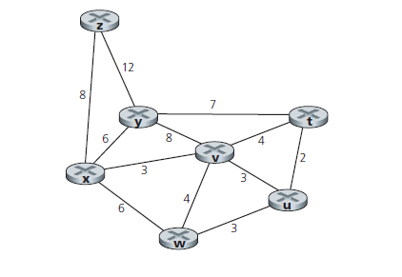

BEST OF LUCK!

